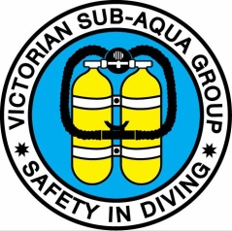

BUDDY CHECK LIST
- Describe dive plan – run time
- What is your separation plan?
- Air turned on?
- Check tank contents (main and redundant bottle) & computer(s) reading
- Test both regs
- Test fin & mask straps
- BCD inflator hose connected, test
- Weight belt secure clasp closed
- Mask anti fog
- Suit done up
- Drysuit inflator hose connected, test
- DSMB/Surface marker buoy attached
- Nautilus attached
- Torch
- Knife
- Compass
- Check additional gear
NOTE FOR SKIPPER…DIVE FLAG UP..

